cnc_rdmacror

声明
/* read custom macro variables(area specified) */
[DllImport("FWLIB32.dll", EntryPoint = "cnc_rdmacror")]
public static extern short cnc_rdmacror(ushort FlibHndl, short a, short b, short c, [Out, MarshalAs(UnmanagedType.LPStruct)] IODBMR d);

描述
读指定范围用户宏变量。（最多读5个用户宏变量）

参数
（1）FlibHndl 库句柄；[ in ]
（2）s_number [ in ]
（3）e_number [ in ]
（4）length [ out ]
（5）macror [ out ]
/* cnc_rdmacror:read custom macro variables(area specified) */
/* cnc_wrmacror:write custom macro variables(area specified) */
[StructLayout(LayoutKind.Sequential, Pack = 4)]
public class IODBMR_data
{
public int mcr_val; /* macro variable */
public short dec_val; /* decimal point */
}
[StructLayout(LayoutKind.Sequential, Pack = 4)]
public class IODBMR1
{
public IODBMR_data data1 = new IODBMR_data();
public IODBMR_data data2 = new IODBMR_data();
public IODBMR_data data3 = new IODBMR_data();
public IODBMR_data data4 = new IODBMR_data();
public IODBMR_data data5 = new IODBMR_data();
} /* In case that the number of data is 5 */
[StructLayout(LayoutKind.Sequential, Pack = 4)]
public class IODBMR
{
public short datano_s; /* start macro number */
public short dummy; /* dummy */
public short datano_e; /* end macro number */
public IODBMR1 data = new IODBMR1();
}

函数返回值
函数运行正常返回EW_OK。
Return code | Meaning/Error handling
EW_LENGTH  (2) | Data block length error  Size of IODBMR structure(length) is wrong.
EW_NUMBER  (3) | Data number error  Custom macro variable number(s_number, e_number) is wrong.
EW_NOOPT  (6) | No option  This function needs the custom macro option.

代码
NC侧实际情况：
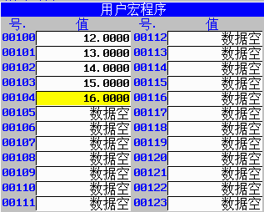
调试结果：
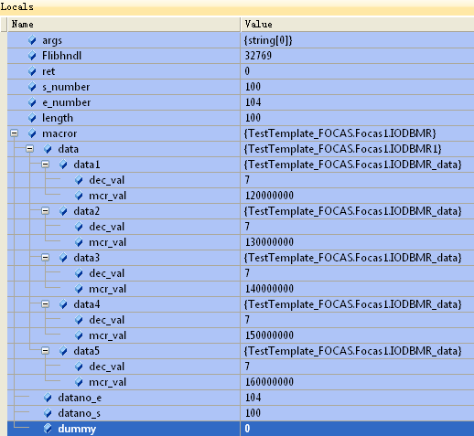
class Program
{
static void Main(string[] args)
{
ushort Flibhndl = 0;

short ret; // 返回值

// 获取库句柄 ( Ethernet )
ret = Focas1.cnc_allclibhndl3("192.168.0.224", 8193, 10, out Flibhndl);
if (ret != Focas1.EW_OK)
{
Console.WriteLine("发生异常，请检查！");
return;
}

#region cnc_rdmacror

short s_number = 100;
short e_number = 104;
short length = 100;
Focas1.IODBMR macror = new Focas1.IODBMR();
ret = Focas1.cnc_rdmacror(Flibhndl, s_number, e_number, length, macror);
#endregion
}
}

